**Chapter 6**

**Power Series**

**6.3 Taylor and Maclaurin Series**

**Section Exercises**

**In the following exercises, find the Taylor polynomials of degree two approximating the given function centered at the given point.**

117. at

Answer: ; ; ; 

119. at

Answer: ; ; 

121. at

Answer: ; ; 

123. at

Answer: 

**In the following exercises, verify that the given choice of *n* in the remainder estimate , where *M* is the maximum value of  on the interval between *a* and the indicated point, yields . Find the value of the Taylor polynomial *pn* of *f* at the indicated point.**

125. **[T]**; , 

Answer:  when  so the remainder estimate applies to the linear approximation , which gives , while .

127. **[T]***e*2; , 

Answer: Using the estimate  we can use the Taylor expansion of order 9 to estimate *ex*at ..as whereas .

129. **[T]**; , 

Answer: Since , . One has whereas 

131. Integrate the approximation  evaluated at –*x*2 to approximate .

Answer: 

whereas 

**In the following exercises, find the smallest value of *n* such that the remainder estimate , where *M* is the maximum value of  on the interval between *a* and the indicated point, yields  on the indicated interval.**

133. on , 

Answer: Since  is or , we have . Since , we seek the smallest *n* such that . The smallest such value is . The remainder estimate is .

135. on , 

Answer: Since  one has . Since , one seeks the smallest *n* such that . The smallest such value is . The remainder estimate is.

**In the following exercises, the maximum of the right-hand side of the remainder estimate  on  occurs at *a*or . Estimate the maximum value of *R* such that  on  by plotting this maximum as a function of *R*.**

137. **[T]** approximated by *x*, 

Answer:

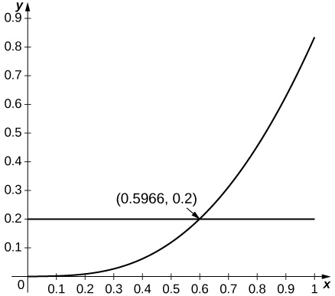

Since  is increasing for small *x* and since the estimate applies whenever , which applies up to .

139. **[T]** approximated by

Answer:

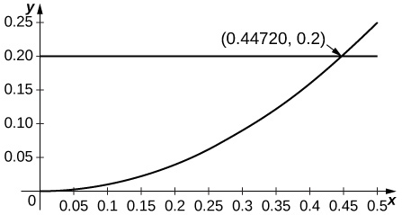

Since the second derivative of  is  and since  is decreasing away from  the estimate applies when or

**In the following exercises, find the Taylor series of the given function centered at the indicated point.**

141. at

Answer: 

143. at

Answer: Values of derivatives are the same as for so

145. at

Answer:  so which is also .

147. at

Answer: The derivatives are so

149. at

Answer: 

**In the following exercises, compute the Taylor series of each function around .**

151. 

Answer: 

153. 

Answer: 

155. 

Answer: 

157. 

Answer: 

159. 

Answer: 

**[T] In the following exercises, identify the value of *x* such that the given series  is the value of the Maclaurin series of at. Approximate the value of using**

161. 

Answer: 

163. 

Answer: 

**The following exercises make use of the functionsandon**

165. **[T]** Ploton Compare the maximum difference with the square of the Taylor remainder estimate for.

Answer:

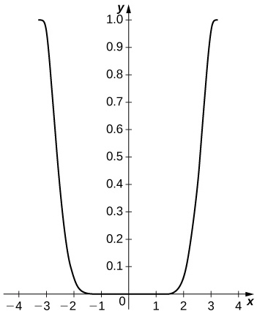

The difference is small on the interior of the interval but approaches  near the endpoints. The remainder estimate is

167. **[T]** Compare on to . Compare this with the Taylor remainder estimate for the approximation of by

Answer:

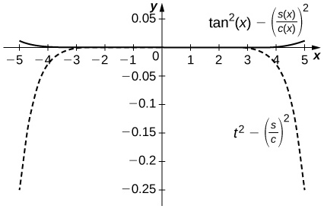

The difference is on the order of onwhile the Taylor approximation error is around near. The top curve is a plot ofand the lower dashed plot shows .

169. (Taylor approximations and root finding.) Recall that Newton's methodapproximates solutions of near the input

1. If **andare inverse functions, explain why a solution of is the value.
2. Letbe the degree Maclaurin polynomial of . Use Newton's method to approximate solutions offor
3. Explain why the approximate roots of  are approximate values of .

Answer: a. Answers will vary. b. The following are the values after iterations of Newton's method to approximation a root of forforfor. (*Note:*) c. Answers will vary.

**In the following exercises, use the fact that if converges in an interval containing , thento evaluate each limit using Taylor series.**

171. 

Answer: 

173. 

Answer: 

**Student Project**

**Proving that  is Irrational**

1. Write the Maclaurin polynomials  for *ex*. Evaluate  to estimate *e*.

Answer:          

3. Using the results from part 2, show that for each remainder  we can find an integer *k* such that  is an integer for 

Answer:     

5. Use Taylor’s theorem to write down an explicit formula for . Conclude that , and therefore, .

Answer:  for some point  between 0 and 1. Since  for any   and therefore, 

This file is copyright 2016, Rice University. All Rights Reserved.